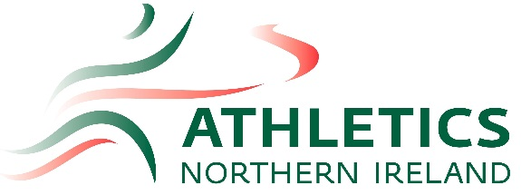
Athletics Northern Ireland International Representation Pathway Information for Para Athletics

This document has been produced to keep athletes, coaches and parents within Northern Ireland informed of their choices in relation to Northern Ireland athletes’ unique dual nationality position. The information below outlines the choices Northern Irish athletes have when they are ready to make representative decisions.

Northern Ireland Representation

Currently, the Commonwealth Games and Commonwealth Youth Games are the only events where Northern Ireland athletes represent Northern Ireland. The Commonwealth Games and Commonwealth Youth Games occur every four years. Selection is made by the relevant Committees. The Commonwealth Games includes Olympic disciplines plus some Para events and the Commonwealth Youth Games includes events sanctioned by the International Amateur Athletics Federation (IAAF) for U18s. Athletics NI nominate athletes for these Championships and those nominations are then put forward to the Northern Ireland Commonwealth Games Council, which is responsible for selecting the Northern Ireland Commonwealth Games Team.
For 2018 Commonwealth Games the Para athletes were selected from IPC rankings and those ranked in the top 8 from Commonwealth countries.

Athletes may represent Northern Ireland at multi-sport events such as the UK School Games and athletes may also represent Northern Ireland & Ulster in competitions such as the Celtic Championships and invitational internationals such as the Manchester International.

Northern Irish athletes will only achieve representation status when selected for an approved Athletics Northern Ireland (ANI) event, having gone through the selection procedure involving Athletics NI. Athletes must also have a National Classification.

Regional and National Schools competitions are not Athletics NI sanctioned events as athletes are representing their school and not Athletics NI.

Northern Ireland Competitions
Athletics NI Championships and selected events – in Northern Ireland para athletes compete with able-bodied athletes apart from wheelchair events which have selected events incorporated into the competitions. For athletes to be included on the results as a para athlete they must have a national classification.
For Athletics NI fixtures https://athleticsni.org/download/files/FixtureList-TrackField060219.pdf
Selection Policies for events are available to view via the Athletics NI website here:
https://athleticsni.org/Athletes/Competition-Opportunities

The Athletics NI Director of Coaching and Athlete Development, Jackie Newton, can be contacted at jackie@athleticsni.org and the Para Athletics Development Lead, Heather Ardis, can be contacted via email at heather@athleticsni.org

British and Irish Representation

Northern Ireland athletes can choose to represent either ‘Great Britain & Northern Ireland’ or ‘Ireland’ if they meet the representation and selection criteria as laid out by British Athletics or Paralympics Ireland respectively. An athlete from Northern Ireland can only represent one country.

Once an athlete is selected for and represents a country, they will have been deemed to have declared their nationality for that country.

Please refer to the website for each governing body for specific performance criteria, scores, staff contact details and any additional conditions for selection:
British Athletics website – https://www.britishathletics.org.uk/
Paralympics Ireland - www.paralympics.ie/

Nationality Transfer
There have been incidences where athletes have decided to change their nationality. This requires approval from and the following documentation:

Governing Body who athlete is moving from (Former Federation)
- One official letter duly signed by the President and/or the Secretary General of the former Federation
Governing Body they wish to declare for (New Federation)
- One official letter duly signed by the President and/or the Secretary General of the new Federation

All cases are reviewed individually by IAAF. Nationality transfers may not take place more than once and there is a minimum three-year waiting period before an athlete may transfer to represent another member. No transfers can take place before the age of 20.

Governing Body Pathways: The information below explains the different stages of the British and Irish Pathways. Athletes can only sit on one pathway. Please note that either governing body may change their structures, or refer to age groups differently, with variances occurring across the disciplines. Please refer to the respective websites for accurate, up to date information as this has been produced to provide guidance only.

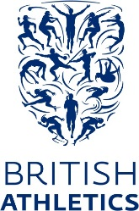
Additional Information for British Athletics:
Once an athlete has elected to represent another nation they will no longer be able to compete at the British Championships unless the Championships are incorporated into another event, in which case, they will not feature in the results of the British Championships element of the competition.

Eligibility:
Athletes are eligible for consideration provided they are:
- A British Citizen holding a United Kingdom passport
- Registered with one of the four home countries
- the minimum age and have met the relevant selection criteria

British Athletics Competitions
- For an athlete’s results to appear on the Power of 10 as a para athlete the athlete must first have a national classification.
- For all Parallel Success events athletes must have a national classification
- BWAA (British Wheelchair Association) Championships athletes must have a national classification
- England AAA Championships – has para events incorporated into the championships athletes must have a national classification
- For a list of Para competitions go to https://www.uka.org.uk/performance/paralympic-performance-pathway/ps-competitions/

Selection Policies:
For Selection Policies please got to:
https://www.uka.org.uk/performance/2019-selection-policies/

World Class Programme:
The British Athletics World Class Performance Programme (“WCPP”) is UK Sport’s National Lottery funded initiative to support the delivery of success at the world’s most significant sporting events, principally the Olympic and Paralympic Games.
During the Tokyo cycle, the aim of the Olympic WCP is to win medals at the Olympic Games, whilst the Paralympic programme is focused on Gold medals. The WCP is structured to reflect these overall aims, as well as supporting the longer-term growth of the sport, and the need to achieve sustained success in Paris and beyond. As a result, the WCP is split into two distinct sections – “Podium” and “Podium Potential". Athletes currently just below WCP level will be considered for the British Athletics Futures Academy Programme.
Membership of the British Athletics WCP is conditional upon athletes entering into an Athlete Agreement. This agreement reflects the fact that the World Class environment is about achieving excellence in everything we do, from meeting challenging performance targets on the sports field to managing ourselves to the highest professional standards. It summarises the services that British Athletics will provide to the athletes and outlines the responsibilities that our leading athletes are expected to observe.
The funding year for the WCP runs from 1st December to the end of November each year. British Athletics conduct a review of each year (currently in October) during which they appoint a selection panel to assess whether athletes should be granted funding for the following year. To decide which athletes should be supported for the following year, the selection panel follow a selection policy (different policies are published for the Olympic and Paralympic programmes), which is available here. Athletes on the Olympic and Paralympic WCP are then be assessed on an ongoing basis to ensure that they continue to meet their targets, and that they maintain realistic medal potential for the future.
Athletes are encouraged to read the WCP Athlete Handbook which outlines the programme including support services, the National Performance Institute, Clean Athletics, Welfare and much more. Please take a read of the document here.

World Class Podium
Youth Academy/ Development Squads
Commonwealth Ambition
World Class Podium Potential
Futures Endurance
Futures Sprints, Relays & Hurdles
Futures Throws, Jumps & Combined Events

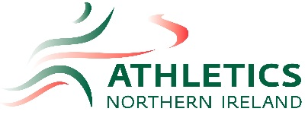
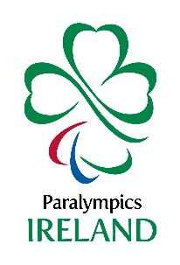
Additional Information for Paralympics Ireland:
Eligibility:

International Representation: In order to represent Ireland, or be eligible to become an Irish Champion, an athlete must hold, or be eligible to hold an Irish passport.

Paralympics Ireland Competitions
Paralympics Ireland, Athletics Ireland and Irish Wheelchair Association Sport incorporate para events in their competitions. For more information visit
https://www.paralympics.ie/getinvolved/
https://iwasport.com/

Carding

To be eligible for the OGPP an athlete must meet with the following requirements:
-Must possess Irish passport and satisfactorily demonstrate that they will be eligible to compete in an
Olympic Games, IAAF and or European Championship event for Ireland.
- Must be a registered member of Athletics Ireland.
- Must not be under suspension or other sanction by IAAF or Athletics Ireland
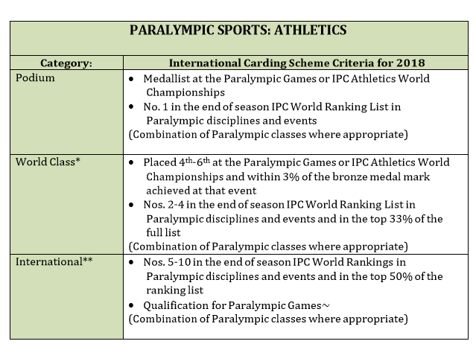
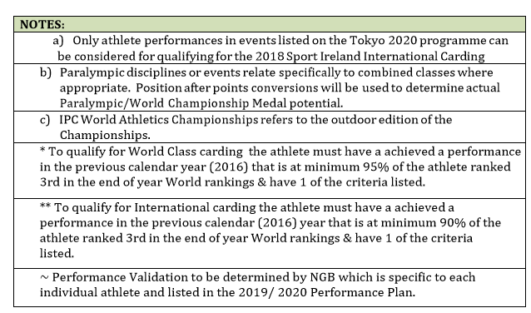

Paralympics Ireland Pathway
Attend Major Championships: WPA European & World Championships & Paralympic Games

Request to be a licensed Paralympic Athlete email: james@paralympics.ie
Compete in domestic competitions
National Classification
Join a club, identify your main event
Goal: Athlete to reach PI Senior panel on merit. 95% of athletes ranked 3rd in World Rankings
Goal: Athlete to reach PI Development panel on merit. 90% of athletes ranked 3rd in World Rankings
FAST-TRACK invitation Paralympics Ireland
International Classification
Classification
Athletes can enter any mainstream club and open competition without a classification. National classification allows eligible athletes to compete in all National Disability Sports Organisations (NDSOs) and UK Athletics competitions including Parallel Success events, and results can then go onto UK Disability Rankings (Power of 10).

National Classification
To represent Great Britain & Northern Ireland or Ireland at a Paralympic, European or World championship event the athlete must first be classified. Classification is a way of defining who is eligible to compete as a Para Athlete. Athletes are assessed by a panel of accredited classifiers and placed in to competition categories, called Sports Classes, according to how their impairment affects sports performance.

International Classification
For an athlete to be eligible to compete at international competition they will need to be internationally classified. The governing body, British Athletics or Paralympics Ireland must put athletes forward for International Classification, this occurs during an international classification.

Non Eligible Impairment Types
To be eligible for classification in Para Athletics, athletes must have an eligible impairment that meets the Minimum Impairment Criteria (MIC) and results from a confirmed underlying health condition. The eligible impairment must be permanent and affect the athlete’s ability to perform the sport. Athletes are required to supply medical diagnostic information that outlines their underlying health condition and primary impairment type before being considered for national classification.

For more information on classification
British Athletics https://www.uka.org.uk/performance/paralympic-performance-programme/national-classification/
Paralympics Ireland https://www.paralympics.ie/classification
.

